

**November 19, 2015**

**Library 407, 10:00AM**

1. Call to Order
2. Executive Committee Reports
   1. President, Amanda Green
   2. Vice-President, David Lambour
   3. Treasurer, Tiffany Soublet
   4. Corresponding Secretary, Brian McDonald
   5. Recording Secretary, William Guillory
3. Committee Reports **(Call for Members)**
   1. Staff Concerns Committee
   2. Events Committee
   3. Awards Committee
   4. Membership/Elections Committee
4. New Business
5. Old Business
6. Guest Speaker: Dr. John W. Nicklow
7. Next Meeting – January 21, 2016
8. Adjournment

Meeting was called to order at 10:05 am.

|  |  |  |
| --- | --- | --- |
| Councilors | Members | Guests |
|  |  |  |
| Amanda Green | Elaine Ramond | Pierre Champagne |
| Tiffany Soublet | Suzy Calamari |  |
| Brian McDonald | Jeanne Augustin |  |
| William Guillory | Kendy Martinez |  |
| Sherlita Gibbs | Carol Milton |  |
| Linda Miller | Kathy Austin |  |
| Norma Mukherjee | Susan Baham |  |
| Carol Lunn | Bill Sheffield |  |
| Marie Kaposchyn | Illia Calix |  |
| David Lambour | Ron Jullian |  |
| Rajni Soharu | Emile Miller |  |
|  | David Armstrong |  |
|  | Jeff Howell |  |
|  | Eric Balukonis |  |
|  | Brydia Dukes |  |
|  | Marilyn Hayden |  |
|  | Sheri Gancheau |  |

**Announcements**

SC President Amanda Green:

* Past meeting minutes (September, October and November) will be voted/approved upon at the January meeting
* Thanks given for those who attended the first presidential search forum held on November 9, 2015
* Requests for meeting with interim President, Randy Moffett, will be pushed back to January 2016
* The agenda was adjusted to allow the guest speaker to begin after executive committee reports were given.

Mary Hoge:

* Lecture and reception by Robert Montjoy at 5pm – the topic of discussion was the upcoming state wide elections on 21Nov2015

Lacy Cunningham:

* Spring Food Drive – suggested forming partnerships to increase collection, such as the Staff Council and the Faculty Senate or NGOs joining together…last year over 70,000 tons of food collected

**Executive Committee Reports**

Vice President David Lambour:

* Highlighted the need for all mandated state compliance training modules be completed and verified by both staff and supervisors in the office of human resources
* Promotes the collection of “stories of service” by staff, so that these individual accomplishments can be shared with the UNO campus family…submit any acts of volunteerism to him

Treasurer Tiffany Soublet:

Account balances remain the same from October report



GUEST SPEAKER – Dr. John W. Nicklow, Provost and Vice President for Academic Affairs

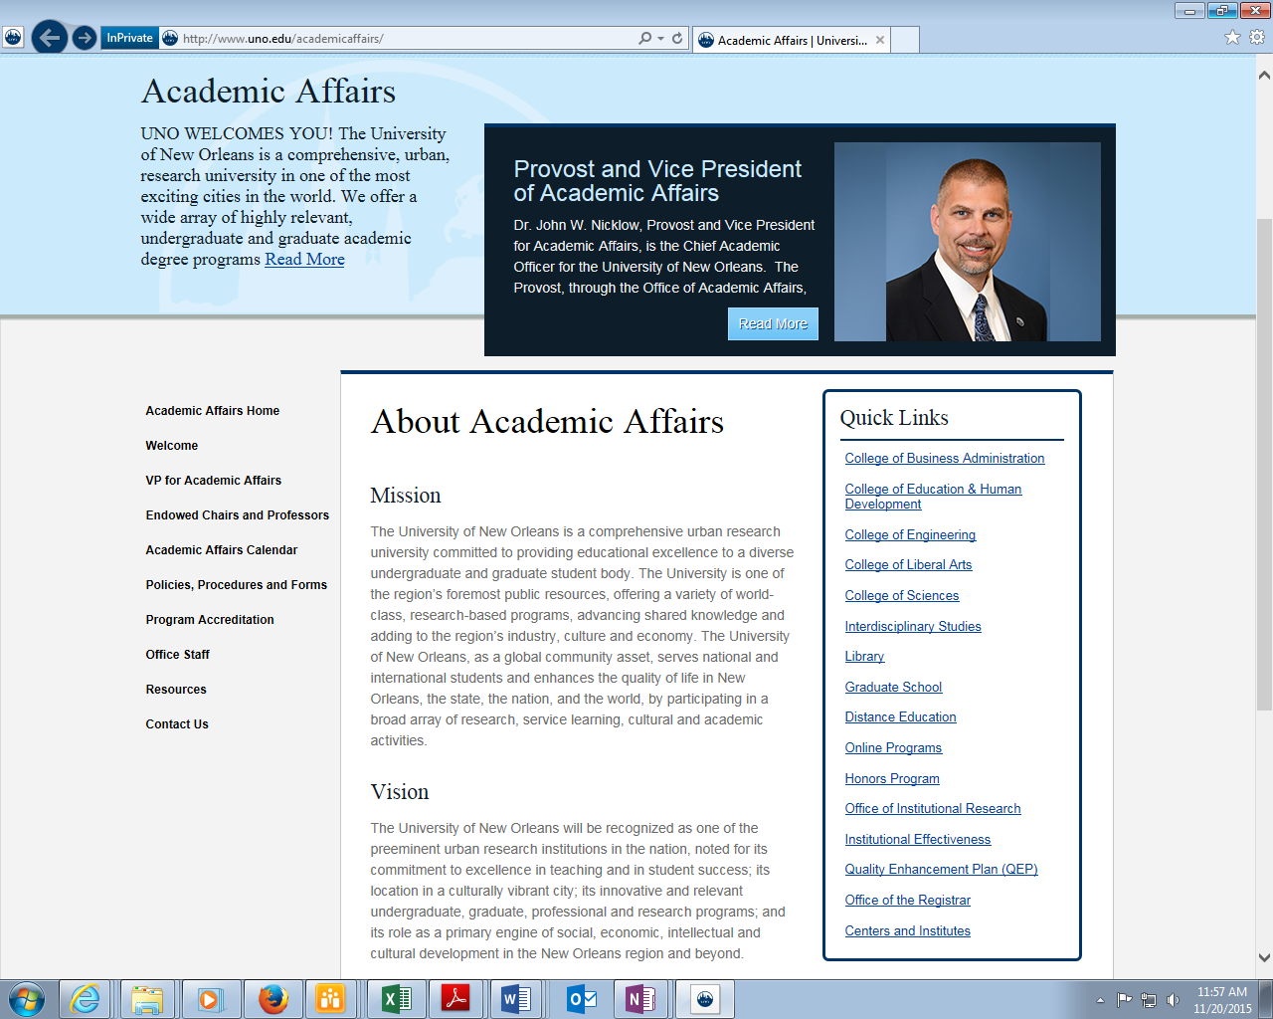

http://www.uno.edu/academicaffairs/

Dr. Nicklow discussed briefly his background, mindset, goals and priorities, enrollment, tuition revenue, retention action teams, new academic programs, and developing partnerships were among the subjects. He wanted to keep his introductory remarks to a minimum and move directly into question/answer to allow more time for an exchange, giving staff the opportunity to move directly to their concerns. This lead to a discussion of a range of issues lasting over 45 minutes.

* Action Teams areas identified for additional focus
* Listening Lunches
* Staff needs awareness and issues with morale
* Declining staff levels in IT
* Upticks in attendance for recruitment events
* Enrollment and retention
* Search Committee for Associate Provost
* Decrease in Student Financial Aid staff levels
* Online education - Creating an “Extended Campus”
* Fee-based tutorial services
* Retention of faculty and staff
* Partnering with Mark Romig and the NOLA Visitors and Tourism Bureau
* Analyze First Time Full Time Freshmen (FTFTF) data from ACT Testing Services to enhance recruitment and retention
* Review recruitment and retention efforts at a retreat and highlight best practices

There was no New Business or Old Business discussed.

The motion to adjoin the meeting was made and seconded.

Meeting adjoined at 11:10am.

Next Meeting is on January 21, 2016 at a new location and time.

The International Center at 1:30pm in the Student Lounge.