Request for Changing the Schedule of Classes
How to fill out the online request form

Introduction
If a class needs to be added, canceled, or modified once the schedule has been created for a specific term, a Request for Changing the Schedule of Classes form must be completed. This will require the signature/approval of the chair of the department, dean of the college, and representative at the registrar’s office. We have recently incorporated the SharePoint version of the form. It can be found here:
https://sharepoint.uno.edu/academicaffairs/registrar/ClassScheduleChanges

Starting the Process
Upon arriving to the website listed above, the following page will be shown.
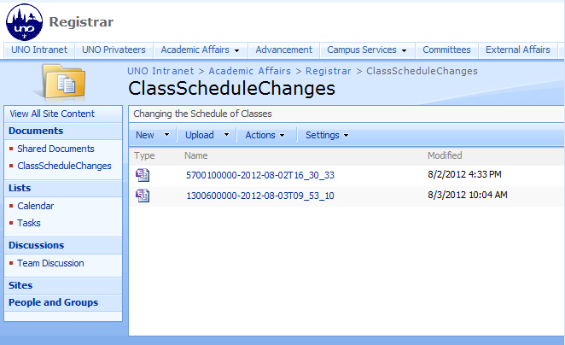
The forms listed on this site are the one currently being processed. To start a new form, click on the New button. The following page will display.
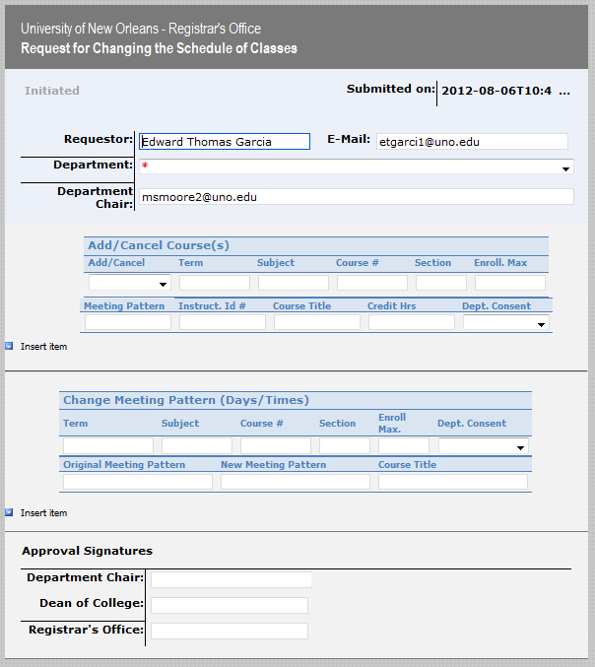

Filling Out the Form
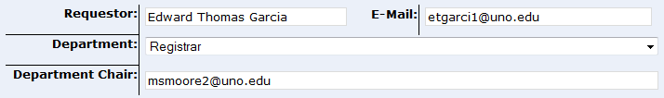
The first section is the requestor’s information and department. The name of the Requestor and E-Mail should automatically be populated. Select the Department to which this form applies. Under Department Chair, ensure the email of the department chair is listed.
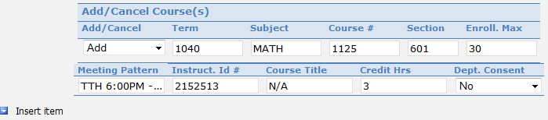
The second section is the Add/Cancel Courses portion of the form. Multiple classes may be added or cancelled via this form by clicking the Insert Item link at the bottom left of this section. To begin, select Add or Cancel. Enter the Term, preferably a term code, ie 1040, but the term will work as well, ie Summer Mini I 2012. Fill out the following course information: Subject, Course #, Section, Enrollment Max, Meeting Pattern, Instructor Id #. If there is a special topic, please include that under Course Title. If the course hours are variable, please specify credit hours or range of credit hours under Credit Hrs.
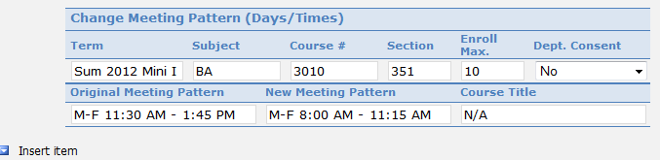
The third section is the Change Meeting Pattern portion of the form. Multiple classes may be changed via this form by clicking the Insert Item link at the bottom left of this section. To begin, enter the Term. Then enter the Subject and Course. If the section number needs changing, enter the new Section. If the enrollment has changed, enter the new Enrollment Max. If department consent has changed, select Yes or No under Dept. Consent. Enter the Original Meeting Pattern and if a change in time is being requested, enter the New Meeting Pattern. If there is a special topic that needs to be assigned, enter it under Course Title.
The final step is to submit the form to the chair of the department by clicking this Submit Button. This button is located at the top left and bottom left of the SharePoint form. After you click the submit button, an email is sent to the department chair for approval. Note: This must be done even if you are the chair of the department.

Post Submit Process
After the form has been submitted, the chair of the department will receive an email and be asked to sign the form. Upon signing and submitting, the dean of the college will receive an email and be asked to sign the form. Upon signing and submitting of the form, the registrar’s office will review and make the requested changes. An email is then sent to everyone involved stating the changes have been made.

