Undergraduate courses are 3000 and 4000 level only. Graduate courses are 5000 and 6000 level only. Please write jstarr1@uno.edu if you need a block lifted.
PRACTICAL FRENCH PHONETICS
French 3002-476, Class #20957 Dr. Celeste E. Conefry 3 credits
xxxxxxxxxxxxxxxxxxxxxxxxxxxxxxxxxxxxxxxxxxxxxxxxxxxxxxxxxxxxxxxxxxxxxxxxxxxxxx
xxxxxxxxxxxxxxxxxxxxxxxxxxxxxxxxxxxxxxxxxxxxxxxxxxxxxxxxxxxxxxxxxxxxx
Required text

Diane Dansereau (2017). Savoir dire, Enhanced 2nd Edition (with Premium Web Site Printed Access Card). Boston: Cengage Learning.

ISBN-10: 1-305-65259-2
ISBN-13: 978-1-305-65259-0
Course description
Phonetics (from the Greek word, phone = voice/sound) is the study of sounds used in speech. This online course will cover the transcription of French discourse using the International Phonetic Alphabet; the terminology necessary for the study of French phonetics and the relationship between French spelling and pronunciation. The students’ speaking abilities will improve as they learn to identify and correct difficulties in the pronunciation of the French language. The course is taught primarily in French.
Requirements
There will be chapter tests, a final exam, and several recording assignments. Students will complete weekly exercises.

INDEPENDENT STUDY
AUDUBON CHARTER SCHOOL
DR. JULIANA STARR
FRENCH 3191-3192-3193-476 CLASS# 20958, 20959, 20960
INTERNET 3 CREDITS
Note: This course is restricted: special departmental permission is required to enroll. Only students in need of it to fulfill a special requirement will be allowed to enroll. Prerequisite: French 2002 or departmental consent. A maximum of 3 credits may be earned per semester. The set of 3 courses 3191-3192- 3193 may be repeated once for credit. The course will be taught in French, on-line. Recently, students have been working as teacher assistants in the French immersion program at Audubon Charter School, then writing about their observations. The work submitted will be done in French.

DEMONSTRATION OF ORAL PROFICIENCY
DR. JULIANA STARR
FRENCH 3197-476 (ONLINE) CLASS # 20961 1 CREDIT

This course is taken concurrently with French 3100 or 3205 or another French 3000+ literature or civilization course. It entails a presentation of a detailed explication de texte in English to the professor teaching the course, and discussion of the chosen text with the professor in a manner designed by him/her. Successful completion of this 1 credit course with the pass/fail grading fulfills the general degree requirement for oral competency in English, which is also a COLAEDHD requirement.

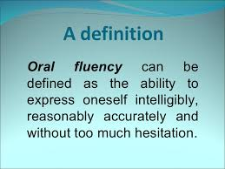

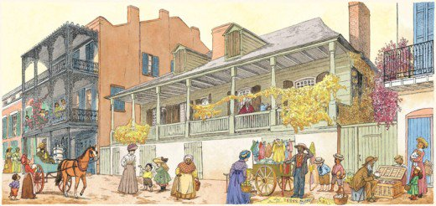

FRENCH 3406.-001 ROMANCE CULTURES OF NEW ORLEANS AND LOUISIANA
Class #20962 - Professor Manuel García-Castellón - 3 CREDITS

Throughout the 18th century, colonial New Orleans developed under the leadership of two powerful Romance cultures: France, which initiated the settlement and gave the colony its original French character, and Spain, that transformed it into a stately city and, as capital of the Spanish Province of Louisiana, gave it administration, laws, architecture, and prosperity. This Romance character was reinforced by the subsequent arrival of Acadians from Canada, Canary islanders, refugees from Haiti, Sephardic Jews, Italians from Calabria and Sicily ... and, more recently, nurtured by the constant influx of refugees or migrants from Latin America, especially after the Katrina disaster. Learning the nature of these original cultural influences will edify the student's appreciation of New Orleans as a melting pot of Romance cultures, in happy conviviality with the American mainstream.
Prerequisites: French or Spanish 2002, or Department consent.
Requirements: A 10-minute in-class presentation, Quizzes., a Final Exam.
Textbook (available through Amazon.com):
Voices from colonial America: Louisiana, 1682-1803. National Geographic, 2006.

TUTORIAL FOR GRADUATING MAJORS
DR. JULIANA STARR

FRENCH 3500-476 (INTERNET) CLASS#: 20963 1 CREDIT
This course prepares majors for the completion of their requirements in the B.A. in Romance Languages-French concentration through advising by a designated professor. The course includes an oral mid-term exam, regular meetings with the advisor to discuss the List of Topics, and the Written Exit Exam, a 2-hour long comprehensive exam written in French. Pass/Fail.
TEXT: “List of Topics,” to be downloaded from the Foreign Languages website, from Moodle, or obtained from Dr. Starr

PROBLEMS OF GRAMMATICAL ANALYSIS

DR. BOURDERIONNET O.
FRENCH 4041-601, CLASS #20964 (undergraduate), 5:00 – 7:45 TH
FRENCH 5041-476, CLASS #20966 (graduate online)
FRENCH 5041-601, CLASS #20967 (graduate onsite), 5:00 – 7:45 TH
3 CREDITS

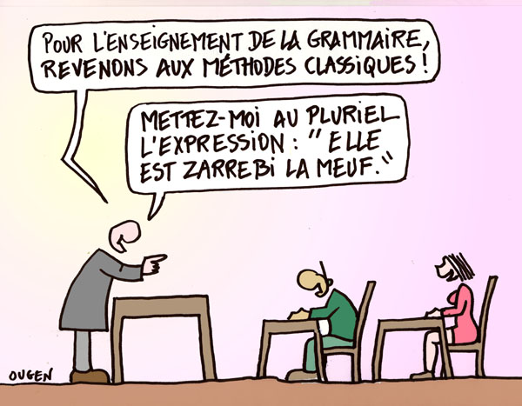
Problems of grammatical analysis and contrastive stylistics will be presented and discussed in this course. Extensive practice in translation exercise, from and into French. Practice material will include grammar drills from textbook, short literary excerpts, song lyrics, comic strips, press documents, etc.
Students will have an opportunity to explore French syntax at a higher level as well as to consolidate their knowledge of it by studying, week after week, the chapters in La grammaire à l’œuvre and by completing exercises provided in the textbook as well as other assignments. All homework will be assigned from the actual textbook or other handouts selected by your instructor. Supplemental material such as magazine advertisement, songs, literary paragraphs, etc. will also be used for translation practice or other forms of class activities.
Grades will be based on a mid-term, a final exam and weekly participation. All students registered online will take the mid-term and final exam via Proctor-U. Online students will submit selected assignments in writing via a Moodle forum and will receive individual feedback on a rotation system. Graduate students will give an oral presentation in class or in video format, on a research topic related to the French language (acquisition, dialects, sociolects, theory of translation, etc.). You will select and propose your topic with the help of your instructor.
Text: Barson, John. La grammaire à l’œuvre (5ème édition). Thomson & Heinle, (2004)
ISBN-10: 075939864X
Physical copy only. We will not be using the online component of La grammaire à l’œuvre.

CHILDREN’S LITERATURE IN FRENCH

FREN 4400-001, class #20965 (undergraduate), 4:30-7:15 T
FREN 5400-476, class #20968 (graduate online)
FREN 5400-601, class #20969 (graduate onsite), 4:30-7:15 T
Dr. DENIS AUGIER
3 CREDITS

In this course we will read famous examples of children’s literature: Charles Perrault’s tales (such as Cendrillon, La Belle au bois dormant…), a selection of La Fontaine’s Fables. We will then examine contemporary examples with Saint Exupéry’s Le Petit Prince, Hergé’s Tintin, and a novel from Enid Blyton’s series Le Club des cinq. With the help of various studies such as Bruno Bettelheim’s La Psychanalyse des contes de fées, Vladimir Propp’sMorphologie du conte and Serge Tisseron’s Tintin chez le psychanaliste, we will systematically investigate the texts to see what kind of disturbing subtext lurks beneath the surface of an apparently straightforward story. A work such as Le Petit Prince – which has often been described as a “child fable for adults” – will introduce us to the ideal of a multi-layered type of children’s literature.

A leading question throughout this course will be: is there such a thing as children’s literature?

There will be a mid-term and a final essay.

Graduate students will have supplementary work on secondary sources, including a presentation.

Required texts: Jean de la Fontaine. Fables choisies. Livres I à VII (Larousse Charles Perrault. Contes (Larousse)
Hergé. Les Bijoux de la Castafiore (Casterman)
Enyd Blyton. Le Club des cinq et le trésor de l’île (Hachette)
Antoine de Saint Exupéry. Le Petit Prince (Gallimard jeunesse)

STUDIES IN FRENCH CULTURE AND CIVILIZATION:
PROSTITUTION IN 19th-CENTURY FRANCE
FRENCH 6295-476 (INTERNET) CLASS #20970
DR. JULIANA STARR
3 CREDITS
Nineteenth-century France saw the most complex, vast, and regulated system of prostitution the world has ever known. The new legislative code of 1791, the end of the Napoleonic era, the advent of the Industrial Revolution, and the rapid growth of the middle class, were contributing factors. At the same time, male artists created images of courtesans and prostitutes to represent their fantasies about female sexuality. Their relation to these figures was complex, involving both identification and repulsion. In this course, we will study a number of historical texts, literary works, and paintings of the Romantic, Realist and Naturalist eras in order to gain insights into these women’s embodiment of the threat of female sexuality and their subjection to strategies of containment. The literary texts will be drawn from the M.A. Reading List for the 19th Century, or will be useable as substitutions for the M.A. Comprehensive Exam. Grading will be based on a bi-weekly assignment or quiz, a four-page book report, a midterm, and a final exam. The texts will be provided by the professor on Moodle and on reserve at the UNO library. For their book report, students will be expected to use their respective local libraries. Note: French 6295 (Studies in French Culture and Civilization) may be taken twice for credit.
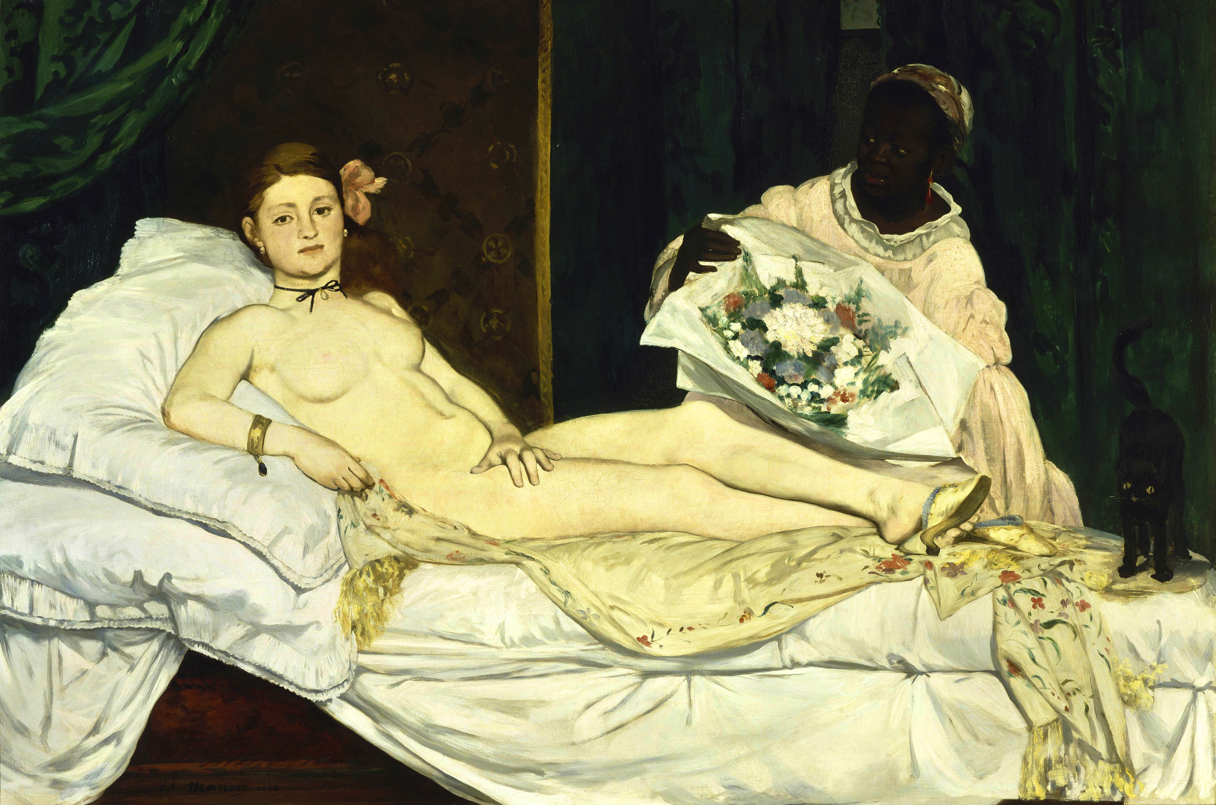

DIRECTED STUDY
DR. JULIANA STARR
FRENCH 6397-476 INTERNET CLASS # 20971 3 CREDITS
This course is restricted: special departmental permission is required to enroll. Only students in need of it to fulfill a special requirement or to complete their degree will be allowed to enroll. Subjects treated this spring: Balzac and Flaubert. Students will read and discuss the following texts on the 19th-Century French Literature Reading List in preparation for the Comprehensive Exam: Le père Goriot, Madame Bovary, Un coeur simple.
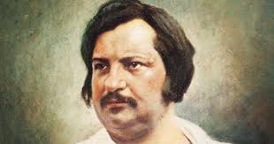

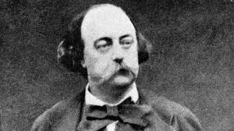

ROML 6003-585 (online)
Applied Romance Linguistics

Class #21846 Dr. Bryant Smith 3 Credit Hours

A study of recent foreign language teaching methods based on current learning theory. Class will include readings, discussions of language methodology, and textbook critiques.

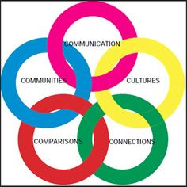

This class, conducted in English, will discuss the evolution of foreign language pedagogy and highlight practices that should be implemented to facilitate meaningful language acquisition. Assignments will include a textbook analysis/critique, active discussion board participation, an essay-based exam, and a final paper/project.
Required text: Teaching Language in Context by Alice Omaggio Hadley (3rd edition). ISBN 978-0838417058
SPANISH PHONETICS
SPAN 3002-001 - 3 CREDITS
CLASS #21902
Prof. Lisbeth A. Philip
MWF 1:00 – 1:50 p.m.
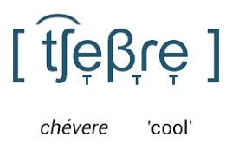

The primary objective of this course is to improve students’ pronunciation in Spanish. The students will learn the articulatory properties of Spanish sounds, how to transcribe these sounds using the International Phonetic Alphabet (IPA), understand and differentiate the main phonological features of regional varieties of Spanish.

There will be in-class oral exercises and quizzes, oral exams, a final project and a final exam.
Required Textbook: Morgan, T.A (2010). Sonidos en contexto: una introducción a la fonética del español con especial referencia a la vida real. Yale University Press.
Print: ISBN: 9780300149593, 030014959X
e-text: ISBN: 9780300165579, 0300165579

SURVEY OF SPANISH LITERATURE I
SPANISH 3100-476 INTERNET CLASS #: 21903 3 CREDITS
DR. ELAINE S. BROOKS

Prerequisite: Spanish 2002 or department consent. This course presents selections and /or complete works by representative writers from Medieval Spain (14th to 16th centuries). We will study narrative forms, poetry, drama and essays with also an overview of the historical period in which each literary work was composed. The student will complete written assignments online in Moodle every week and each student will write two papers, 5 pages in length during the semester. Lectures will be uploaded in Moodle and participation in the Discussion Board forums is mandatory. The course will be conducted in English, but all readings are in Spanish. There will be a midterm and final exam.
Required text: Rodney T. Rodriguez. Momentos cumbres de las literaturas hispánicas. New Jersey: Prentice Hall, 2003. ISBN: 0-13-140132-7. There will be a copy of the textbook in the library for consultation.

El Cid Campeador

INDEPENDENT STUDY
DR. JOKE MONDADA
SPANISH 3191-3192-3193-495 CLASS # 21904, 21905, 21906
HYBRID 3 CREDITS
Note: This course is restricted: special departmental permission is required to enroll. Only students in need of it to fulfill a special requirement will be allowed to register. Prerequisite: Spanish 2002 or departmental consent. A maximum of 3 credits may be earned per semester. The set of 3 courses 3191-3192-3193 may be repeated once for credit. The course will be taught in Spanish.
Topics treated in recent semesters: Spanish Phonetics; Readings in Spanish Poetry; the Analysis of the Short Story.

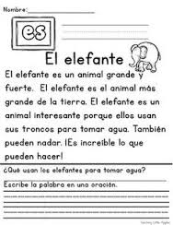

DEMONSTRATION OF ORAL PROFICIENCY
DR. ELAINE BROOKS
SPANISH 3197-476 (INTERNET) CLASS #21907 1 CREDIT
This course is taken concurrently with Spanish 3100, 3101 or Spanish 3271 or similar courses. It entails a presentation of a detailed commentario de texto in English to the professor teaching the course, and discussion of the chosen text with the professor in a manner designed by him/her. Successful completion of this 1 credit course with the pass/fail grading fulfills the general degree requirement for oral competency in English, which is also a COLAEDHD requirement.

SPANISH 3406.-001 ROMANCE CULTURES OF NEW ORLEANS AND LOUISIANA
Class #21908 - Professor Manuel García-Castellón - 3 CREDITS

Throughout the 18th century, colonial New Orleans developed under the leadership of two powerful Romance cultures: France, which initiated the settlement and gave the colony its original French character, and Spain, that transformed it into a stately city and, as capital of the Spanish Province of Louisiana, gave it administration, laws, architecture, and prosperity. This Romance character was reinforced by the subsequent arrival of Acadians from Canada, Canary islanders, refugees from Haiti, Sephardic Jews, Italians from Calabria and Sicily ... and, more recently, nurtured by the constant influx of refugees or migrants from Latin America, especially after the Katrina disaster. Learning the nature of these original cultural influences will edify the student's appreciation of New Orleans as a melting pot of Romance cultures, in happy conviviality with the American mainstream.
Prerequisites: French or Spanish 2002, or Department consent.
Requirements: A 10-minute in-class presentation, Quizzes., a Final Exam.
Textbook (available through Amazon.com):
Voices from colonial America: Louisiana, 1682-1803. National Geographic, 2006.

TUTORIAL FOR GRADUATING MAJORS
DR. JULIANA STARR

SPANISH 3500-476 (INTERNET) CLASS#: 21909 1 CREDIT

This course prepares majors for the completion of their requirements in the B.A. in Romance Languages-Spanish concentration through advising by a designated professor. The course includes an oral mid-term exam, regular meetings with the advisor to discuss the List of Topics, and the Written Exit Exam, a 2-hour long comprehensive exam written in Spanish. Pass/Fail.
TEXT: “List of Topics,” to be downloaded from the Foreign Languages website or from Moodle, or obtained from Dr. Starr

Translation and Interpreting in the Healthcare Setting
SPAN 4171-495 (undergraduate class #21976) / 5171-495 (graduate class #21977)
(Hybrid: online with an on-campus component.
Note: The onsite component is mandatory for all students enrolled in this course)
On-campus class time: Mondays 6:30 p.m. – 9:15 p.m.
Prof. Lisbeth A. Philip, CHITM
Certified Healthcare Interpreter

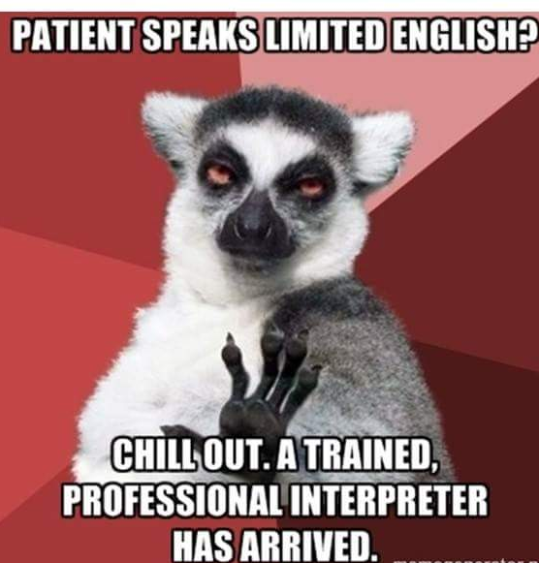

This course, which has a two-part component, one in translation (online) and the other in interpreting (onsite), is designed to introduce students to the discipline of translation and interpreting in the healthcare setting. In this course, students will develop skills to safely and accurately convey health-related topics to and from Spanish. The knowledge and skills developed in this course will contribute to effective communication between patients and with limited English proficiency (LEP) and their healthcare providers in treatment and services, in a manner that meets the patients’ written and oral communication needs. This course will include and intensive study of medical vocabulary, grammar, sentence structure, and translation difficulties. It will also cover intensive practical training techniques in the three modes of interpreting (sight translation, consecutive and simultaneous) in the healthcare setting. An overview of the profession of healthcare interpreting and aspects of language and communication dynamics as they impact interpreting will be discussed in detail.

Given the nature of the course of study, we will fluctuate between Spanish and English, depending on the object of our discussion or on the direction in which we are translating and interpreting.

Required Texts: There is no textbook required for this course. All Readings and other required materials will be made available in Moodle in a timely manner.
SPANISH AMERICAN CIVILIZATION AND CULTURE I
From the Discovery to the Emergence of Nations
SPANISH 4203 (undergraduate class #21910 / SPANISH 5203-476 (graduate class #21911)
ONLINE DR. MANUEL GARCIA-CASTELLON 3 CREDITS
This course, conducted in Spanish, will acquaint the student with the general and fundamental ideas about the cultural history of Colonial Latin America, i.e., from the Discovery of the New World and throughout the colonial period until the emergence of the Latin American nations after their struggles for independence. Essays, chronicles, documentary texts, occasionally some literary excerpts, and media (all downloaded from Internet sources), as well as the chapters in our main textbook (i.e. Burkholder & Lyman´s Colonial Latin America) will be our main sources of documentation.
Requirements: Graduate Students will answer weekly questionnaires based on Burkholder’s chapters. They will also comment in Spanish on documents downloaded from Internet sources regarding the formation of the Hispanic American culture. A final 7-10 page term paper in MLA format is also required.
Undergraduate Students will also answer the weekly questionnaires on Burkholder’s textbook in Spanish. Occasionally they will comment on media or documents regarding cultural subjects such as music, arts, and crafts. A final 5-7 page term paper in MLA format is also required.
REQUIRED TEXT: Mark A. Burkholder & Lyman L. Johnson. Colonial Latin America. Sixth Edition.

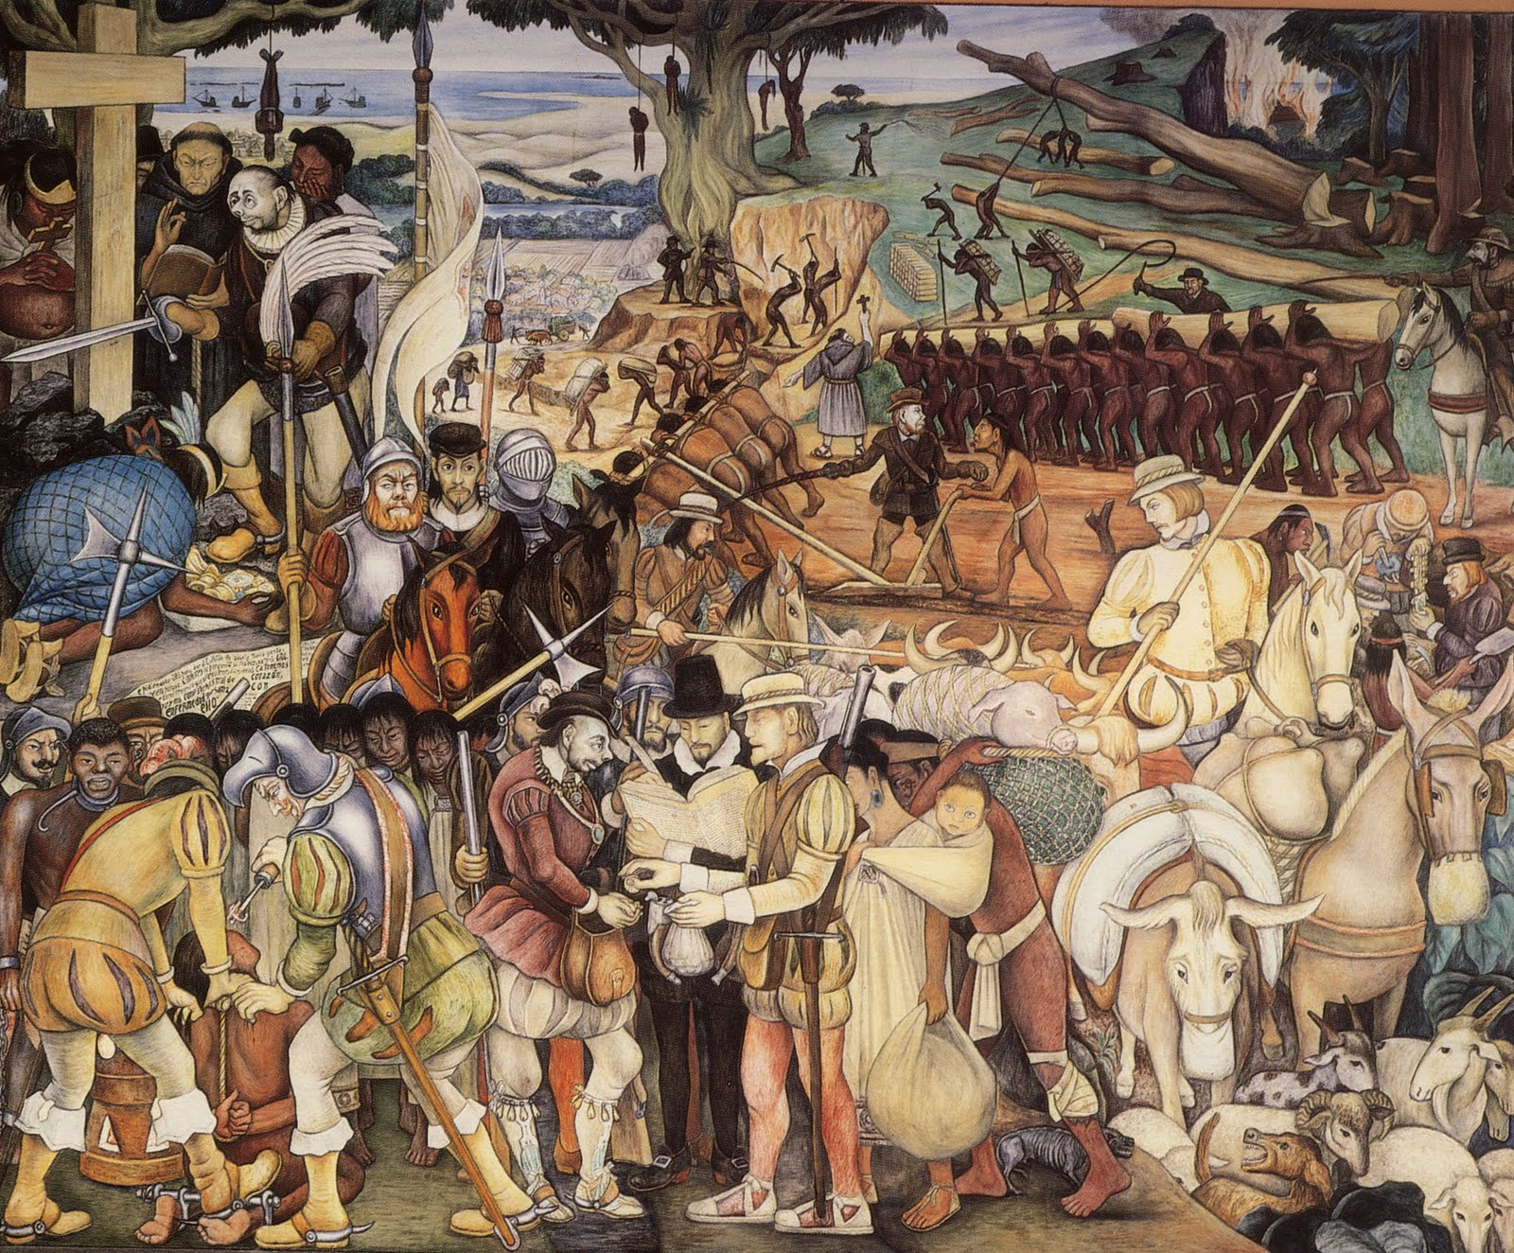

Spanish 6191-585:
Studies in Golden Age Literature
Internet Class #21912 STAFF 3 cr.

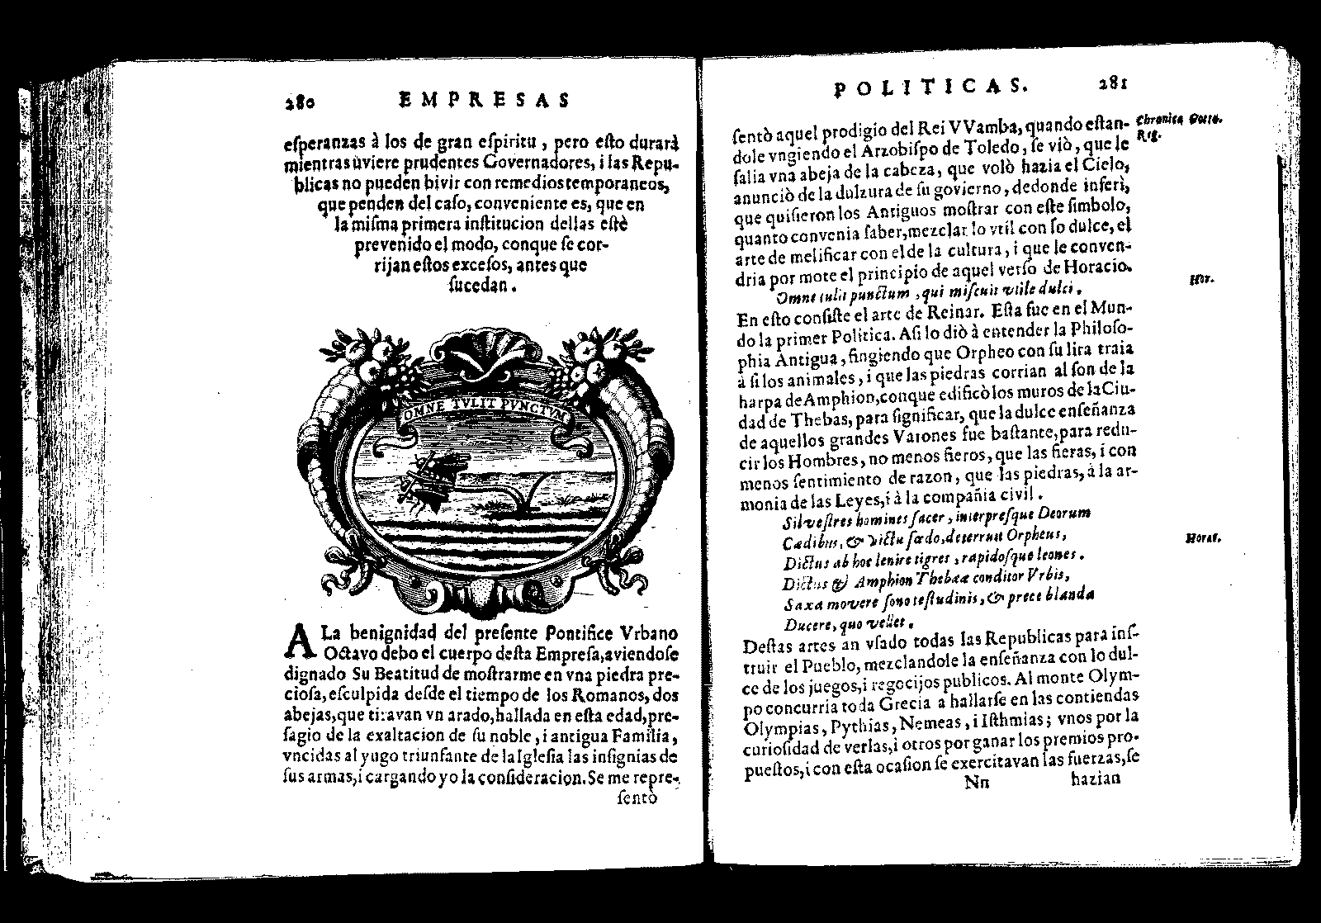

STUDIES IN SPANISH LITERATURE:
EL MODERNISMO
SPAN 6198-476 (online)
INTERNET Class #21913 3 CREDITS
Dr. Manuel García-Castellón
This course, conducted in Spanish, will familiarize the student with “Modernismo,” a literary movement appearing in the Hispanic world in the final decades of the 19th century and lasting until the early 1920’s. Originally indebted to French Parnassianism (impeccable form, high plasticity in imagery, return to classical metrics) and Symbolism (mysticism and esoterism), and coinciding with the artistic worlds of Alphonse Mucha and Antonio Gaudí, among others, it opened a bright period of literary innovation in the poetry and prose of America and Spain. As a movement of rupture with and aversion to contemporary society, its creators sought idealized worlds, often medieval or exotic. They also embraced esoteric doctrines, shown in their interest for things hidden and mysterious and in a desire to communicate with the afterlife. To develop their analytic capabilities for textual explication of works, students will be provided with the tools of poetic and rhetoric analysis, as well as with documents on conditions of textual production. Special attention will be given to figures of speech in poetry excerpts.
Requirements: weekly readings and questionnaires. A 8/10 page term paper including analysis of a text not seen before during the semester.
Text: An Anthology of Spanish American Modernismo, in English translation with Spanish Text. Ed. By Kelly Washbourne & Sergio Waisman. MLA, New York 2007 (Available through Amazon.com)
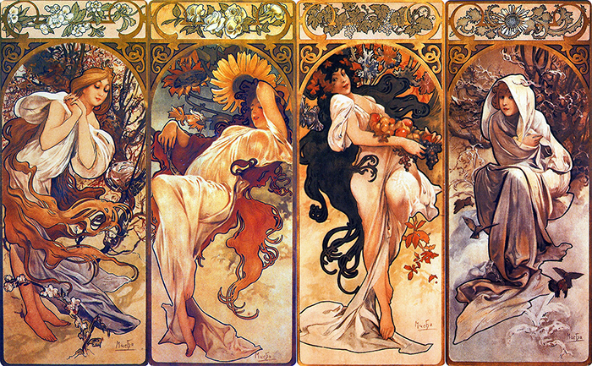
DIRECTED STUDY
DR. MANUEL GARCÍA-CASTELLÓN
SPAN 6397- 476 INTERNET CLASS #: 21914 3 CREDITS
This course is restricted: special departmental permission is required to enroll. Only students in need of it to fulfill a special requirement will be allowed to register.
Topics in recent semesters: Golden Age Literature including Cervantes; early Spanish Civilization; Women writers.

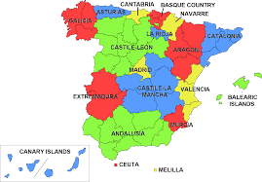

On-campus component will begin March 11 (Week eight)

